Current process:

Today in the shipment central backend integration process we have a dependency with APP Dev team , as they connect to RailroadAPI’s and gets the information from each vendor (CN,CSXT,BNSF,NS,UP) AND drops that data in csv files format for every 30 . But this information is very limited at this time and we only receive data for Next planned move and get ETA (Estimated Time of Arrival) for each car which has open trip status.

Now IN the New process is : we are eliminating this dependency and as part of the (Data engineering ) process will directly connect to each VENDOR API and extract all the fields available for that API , each API has its own limitations based on that we extract the data for all the cars which has open trip status . Now the criteria and authentication type is different fr each API, sean O loughlin helped us a lot to get this WORK done.

Here are the refresh intervals for each vendor, these schedules were discussed and are the closest refresh based on the execution times of each API.

These are the 7 files in Daas

CSXT :

* + Retrieve open status car numbers for CSXT vendors from Shipment Details.
  + Iterate through the car numbers, sending individual API requests with the bearer token for each car

CN:

* + Request API with “All” to get all the equipment information.
  + Download information from below four APIs and merge into one

1. eta 2. gpslocation 3.shipmentstatus 4.billoflading

* + Filter EquipmentWaybillStatus = 'Executing'

BNSF – 2 API

* + ETA information from each API response

Trip details

NS: EVERY10 CARS

**Download data from equipmentstatus, equipmenttripplanstatus :**

UP: ONE CAR

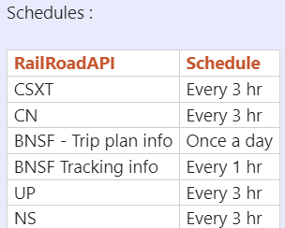

Daas :

